**17.VEHICLE REGISTRATION SYSTEM**

**1) USE CASE DIAGRAM**

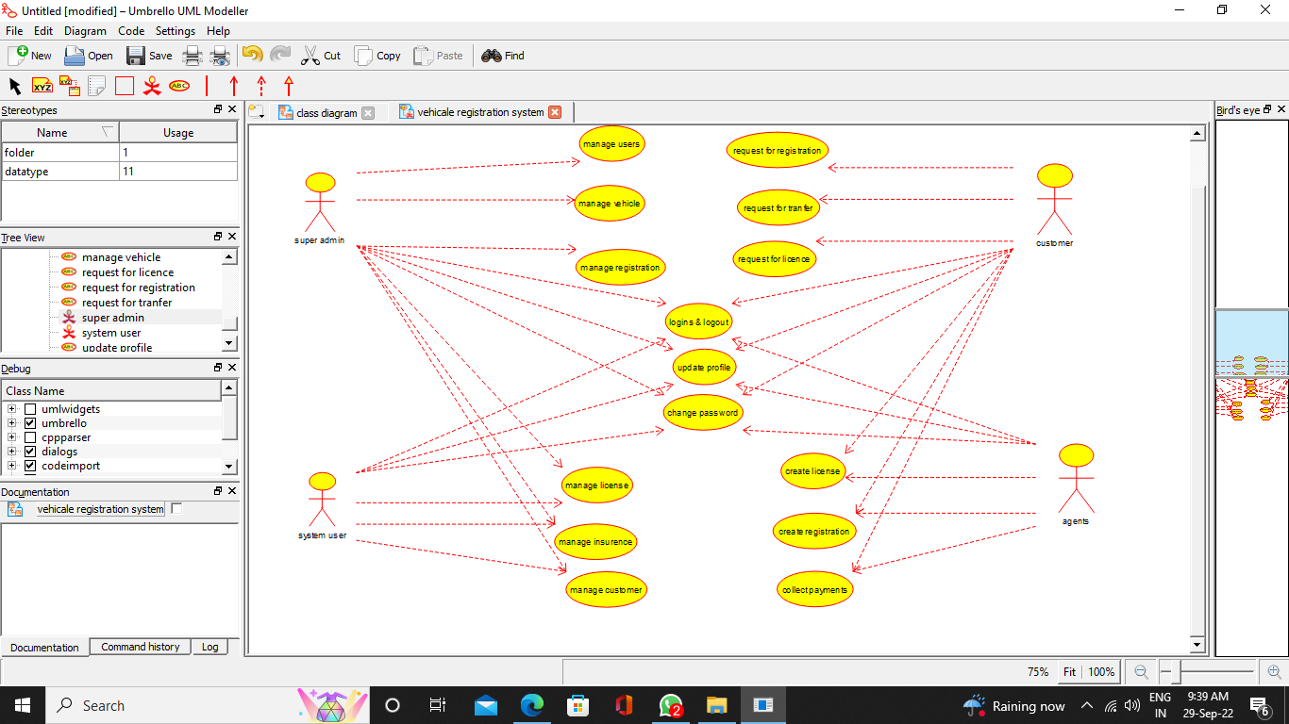

**2) CLASS DIAGRAM**

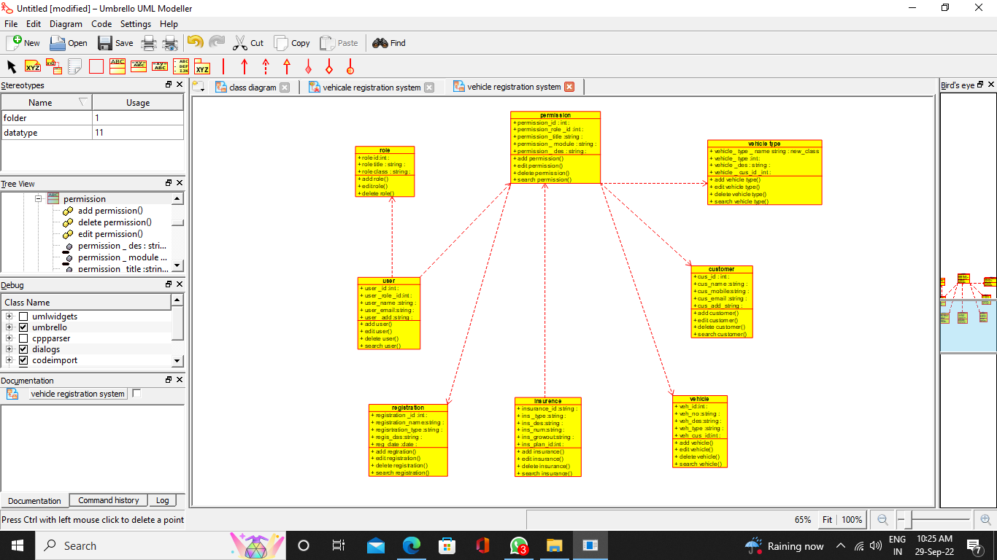

**3) ACTIVITY DIAGRAM**

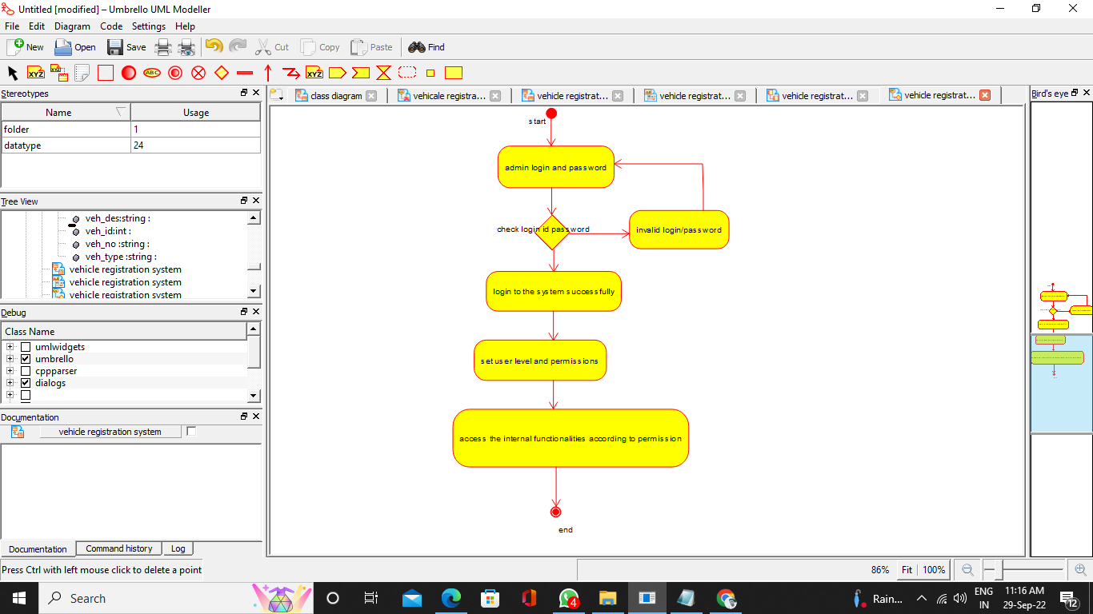

**4)SEQUENCE DIAGRAM**

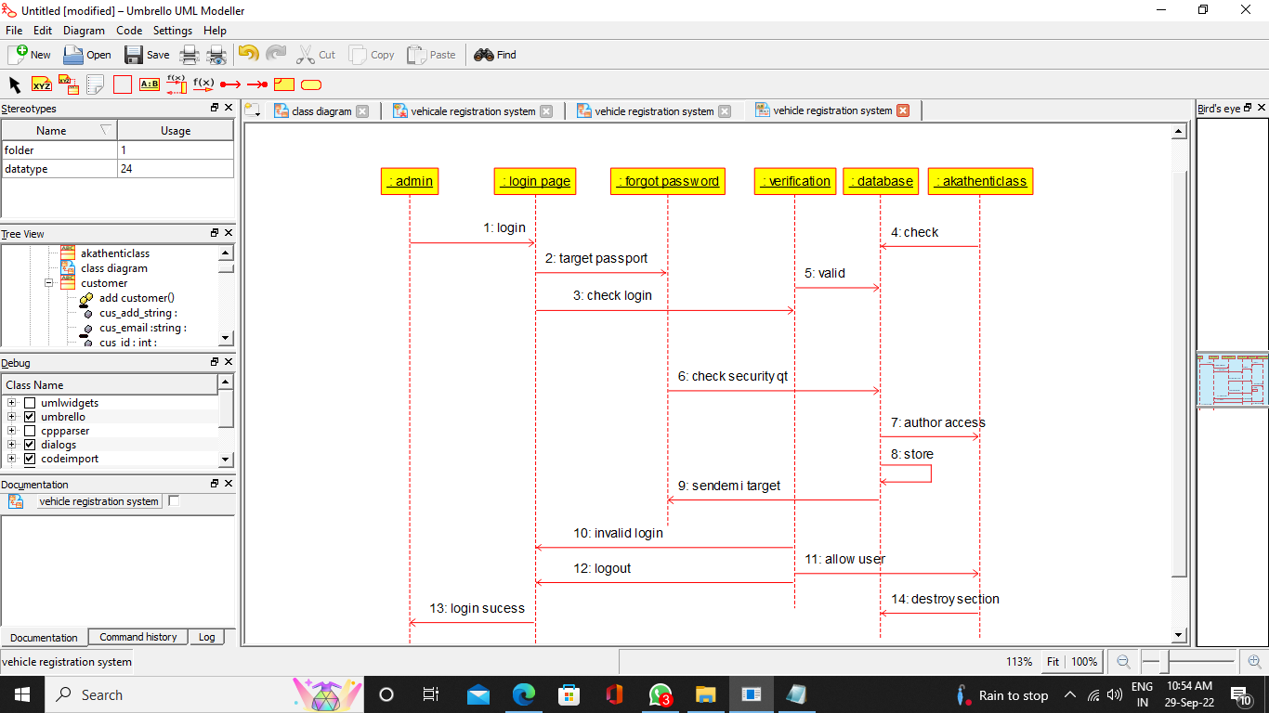

**5) COLLABORATION DIAGRAM**

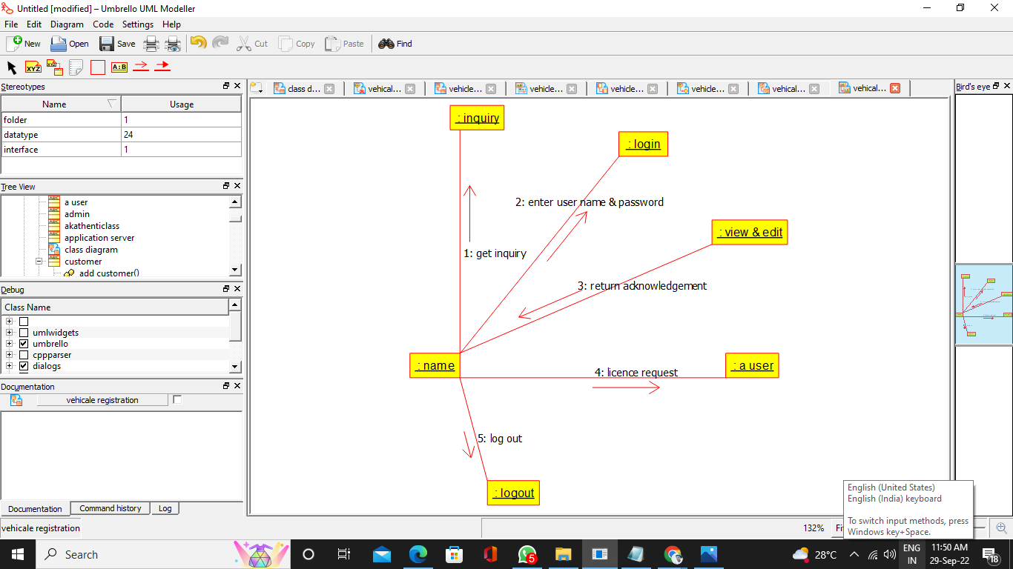

**6) COMPONENT DIAGRAM**

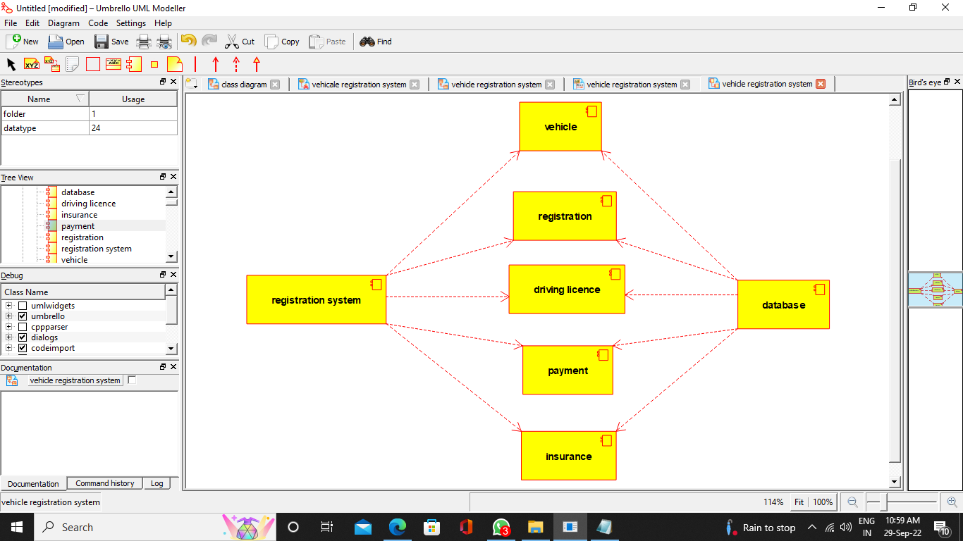

**7) DEPLOYMENT DIAGRAM**

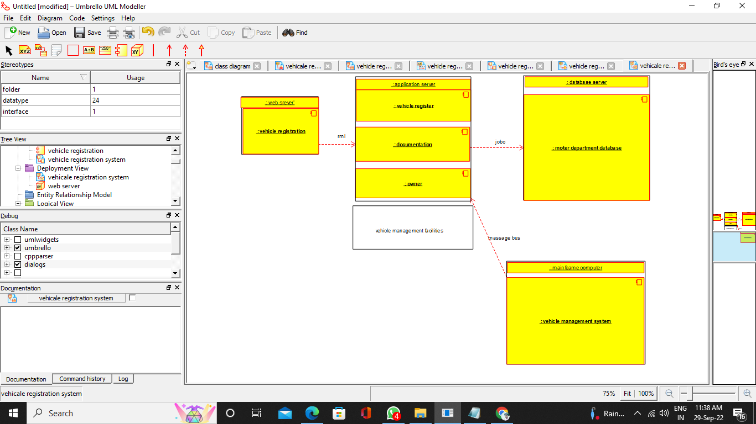

**PROGRAM CODE:**

/**

* Class customer

*/

public class customer {

//

// Fields

//

public void cus_id_int;

public void cus_name_string;

public void cus_mobile_string;

public void cus_email_string;

public void cus_add_string;

//

// Constructors

//

public customer () { };

//

// Methods

//

//

// Accessor methods

//

/**

* Set the value of cus_id_int

* @param newVar the new value of cus_id_int

*/

public void setCus_id_int (void newVar) {

cus_id_int = newVar;

}

/**

* Get the value of cus_id_int

* @return the value of cus_id_int

*/

public void getCus_id_int () {

return cus_id_int;

}

/**

* Set the value of cus_name_string

* @param newVar the new value of cus_name_string

*/

public void setCus_name_string (void newVar) {

cus_name_string = newVar;

}

/**

* Get the value of cus_name_string

* @return the value of cus_name_string

*/

public void getCus_name_string () {

return cus_name_string;

}

/**

* Set the value of cus_mobile_string

* @param newVar the new value of cus_mobile_string

*/

public void setCus_mobile_string (void newVar) {

cus_mobile_string = newVar;

}

/**

* Get the value of cus_mobile_string

* @return the value of cus_mobile_string

*/

public void getCus_mobile_string () {

return cus_mobile_string;

}

/**

* Set the value of cus_email_string

* @param newVar the new value of cus_email_string

*/

public void setCus_email_string (void newVar) {

cus_email_string = newVar;

}

/**

* Get the value of cus_email_string

* @return the value of cus_email_string

*/

public void getCus_email_string () {

return cus_email_string;

}

/**

* Set the value of cus_add_string

* @param newVar the new value of cus_add_string

*/

public void setCus_add_string (void newVar) {

cus_add_string = newVar;

}

/**

* Get the value of cus_add_string

* @return the value of cus_add_string

*/

public void getCus_add_string () {

return cus_add_string;

}

//

// Other methods

//

/**

*/

public void add_customer()

{

}

/**

*/

public void edit_customer()

{

}

/**

*/

public void delete_customer()

{

}

/**

*/

public void search_customer()

{

}

}

/**

* Class insurence

*/

public class insurence {

//

// Fields

//

public void insurance_id_string;

public void ins__type_string;

public void ins_des_string;

public void ins_num_string;

public void ins_growout_string;

public void ins_plan_id_int;

//

// Constructors

//

public insurence () { };

//

// Methods

//

//

// Accessor methods

//

/**

* Set the value of insurance_id_string

* @param newVar the new value of insurance_id_string

*/

public void setInsurance_id_string (void newVar) {

insurance_id_string = newVar;

}

/**

* Get the value of insurance_id_string

* @return the value of insurance_id_string

*/

public void getInsurance_id_string () {

return insurance_id_string;

}

/**

* Set the value of ins__type_string

* @param newVar the new value of ins__type_string

*/

public void setIns__type_string (void newVar) {

ins__type_string = newVar;

}

/**

* Get the value of ins__type_string

* @return the value of ins__type_string

*/

public void getIns__type_string () {

return ins__type_string;

}

/**

* Set the value of ins_des_string

* @param newVar the new value of ins_des_string

*/

public void setIns_des_string (void newVar) {

ins_des_string = newVar;

}

/**

* Get the value of ins_des_string

* @return the value of ins_des_string

*/

public void getIns_des_string () {

return ins_des_string;

}

/**

* Set the value of ins_num_string

* @param newVar the new value of ins_num_string

*/

public void setIns_num_string (void newVar) {

ins_num_string = newVar;

}

/**

* Get the value of ins_num_string

* @return the value of ins_num_string

*/

public void getIns_num_string () {

return ins_num_string;

}

/**

* Set the value of ins_growout_string

* @param newVar the new value of ins_growout_string

*/

public void setIns_growout_string (void newVar) {

ins_growout_string = newVar;

}

/**

* Get the value of ins_growout_string

* @return the value of ins_growout_string

*/

public void getIns_growout_string () {

return ins_growout_string;

}

/**

* Set the value of ins_plan_id_int

* @param newVar the new value of ins_plan_id_int

*/

public void setIns_plan_id_int (void newVar) {

ins_plan_id_int = newVar;

}

/**

* Get the value of ins_plan_id_int

* @return the value of ins_plan_id_int

*/

public void getIns_plan_id_int () {

return ins_plan_id_int;

}

//

// Other methods

//

/**

*/

public void add_insurance()

{

}

/**

*/

public void edit_insurance()

{

}

/**

*/

public void delete_insurance()

{

}

/**

*/

public void search_insurance()

{

}

}

/**

* Class permission

*/

public class permission {

//

// Fields

//

public void permission_id_int;

public void permission_role__id_int;

public void permission__title_string;

public void permission___module_string;

public void permission___des_string;

//

// Constructors

//

public permission () { };

//

// Methods

//

//

// Accessor methods

//

/**

* Set the value of permission_id_int

* @param newVar the new value of permission_id_int

*/

public void setPermission_id_int (void newVar) {

permission_id_int = newVar;

}

/**

* Get the value of permission_id_int

* @return the value of permission_id_int

*/

public void getPermission_id_int () {

return permission_id_int;

}

/**

* Set the value of permission_role__id_int

* @param newVar the new value of permission_role__id_int

*/

public void setPermission_role__id_int (void newVar) {

permission_role__id_int = newVar;

}

/**

* Get the value of permission_role__id_int

* @return the value of permission_role__id_int

*/

public void getPermission_role__id_int () {

return permission_role__id_int;

}

/**

* Set the value of permission__title_string

* @param newVar the new value of permission__title_string

*/

public void setPermission__title_string (void newVar) {

permission__title_string = newVar;

}

/**

* Get the value of permission__title_string

* @return the value of permission__title_string

*/

public void getPermission__title_string () {

return permission__title_string;

}

/**

* Set the value of permission___module_string

* @param newVar the new value of permission___module_string

*/

public void setPermission___module_string (void newVar) {

permission___module_string = newVar;

}

/**

* Get the value of permission___module_string

* @return the value of permission___module_string

*/

public void getPermission___module_string () {

return permission___module_string;

}

/**

* Set the value of permission___des_string

* @param newVar the new value of permission___des_string

*/

public void setPermission___des_string (void newVar) {

permission___des_string = newVar;

}

/**

* Get the value of permission___des_string

* @return the value of permission___des_string

*/

public void getPermission___des_string () {

return permission___des_string;

}

//

// Other methods

//

/**

*/

public void add_permission()

{

}

/**

*/

public void edit_permission()

{

}

/**

*/

public void delete_permission()

{

}

/**

*/

public void search_permission()

{

}

}

/**

* Class registration

*/

public class registration {

//

// Fields

//

public void registration__id_int;

public void registration_name_string;

public void regisrtration_type_string;

public void regis_das_string;

public void reg_date_date;

//

// Constructors

//

public registration () { };

//

// Methods

//

//

// Accessor methods

//

/**

* Set the value of registration__id_int

* @param newVar the new value of registration__id_int

*/

public void setRegistration__id_int (void newVar) {

registration__id_int = newVar;

}

/**

* Get the value of registration__id_int

* @return the value of registration__id_int

*/

public void getRegistration__id_int () {

return registration__id_int;

}

/**

* Set the value of registration_name_string

* @param newVar the new value of registration_name_string

*/

public void setRegistration_name_string (void newVar) {

registration_name_string = newVar;

}

/**

* Get the value of registration_name_string

* @return the value of registration_name_string

*/

public void getRegistration_name_string () {

return registration_name_string;

}

/**

* Set the value of regisrtration_type_string

* @param newVar the new value of regisrtration_type_string

*/

public void setRegisrtration_type_string (void newVar) {

regisrtration_type_string = newVar;

}

/**

* Get the value of regisrtration_type_string

* @return the value of regisrtration_type_string

*/

public void getRegisrtration_type_string () {

return regisrtration_type_string;

}

/**

* Set the value of regis_das_string

* @param newVar the new value of regis_das_string

*/

public void setRegis_das_string (void newVar) {

regis_das_string = newVar;

}

/**

* Get the value of regis_das_string

* @return the value of regis_das_string

*/

public void getRegis_das_string () {

return regis_das_string;

}

/**

* Set the value of reg_date_date

* @param newVar the new value of reg_date_date

*/

public void setReg_date_date (void newVar) {

reg_date_date = newVar;

}

/**

* Get the value of reg_date_date

* @return the value of reg_date_date

*/

public void getReg_date_date () {

return reg_date_date;

}

//

// Other methods

//

/**

*/

public void add_regtration()

{

}

/**

*/

public void edit_registration()

{

}

/**

*/

public void delete_registration()

{

}

/**

*/

public void search_registration()

{

}

}

/**

* Class role

*/

public class role {

//

// Fields

//

public void role_id_int;

public void role_title_string;

public void role_class_string;

//

// Constructors

//

public role () { };

//

// Methods

//

//

// Accessor methods

//

/**

* Set the value of role_id_int

* @param newVar the new value of role_id_int

*/

public void setRole_id_int (void newVar) {

role_id_int = newVar;

}

/**

* Get the value of role_id_int

* @return the value of role_id_int

*/

public void getRole_id_int () {

return role_id_int;

}

/**

* Set the value of role_title_string

* @param newVar the new value of role_title_string

*/

public void setRole_title_string (void newVar) {

role_title_string = newVar;

}

/**

* Get the value of role_title_string

* @return the value of role_title_string

*/

public void getRole_title_string () {

return role_title_string;

}

/**

* Set the value of role_class_string

* @param newVar the new value of role_class_string

*/

public void setRole_class_string (void newVar) {

role_class_string = newVar;

}

/**

* Get the value of role_class_string

* @return the value of role_class_string

*/

public void getRole_class_string () {

return role_class_string;

}

//

// Other methods

//

/**

*/

public void add_role()

{

}

/**

*/

public void edit_role()

{

}

/**

*/

public void delete_role()

{

}

}

/**

* Class user

*/

public class user {

//

// Fields

//

public void user__id_int;

public void user__role__id_int;

public void user_name_string;

public void user_email_string;

public void user__add_string;

//

// Constructors

//

public user () { };

//

// Methods

//

//

// Accessor methods

//

/**

* Set the value of user__id_int

* @param newVar the new value of user__id_int

*/

public void setUser__id_int (void newVar) {

user__id_int = newVar;

}

/**

* Get the value of user__id_int

* @return the value of user__id_int

*/

public void getUser__id_int () {

return user__id_int;

}

/**

* Set the value of user__role__id_int

* @param newVar the new value of user__role__id_int

*/

public void setUser__role__id_int (void newVar) {

user__role__id_int = newVar;

}

/**

* Get the value of user__role__id_int

* @return the value of user__role__id_int

*/

public void getUser__role__id_int () {

return user__role__id_int;

}

/**

* Set the value of user_name_string

* @param newVar the new value of user_name_string

*/

public void setUser_name_string (void newVar) {

user_name_string = newVar;

}

/**

* Get the value of user_name_string

* @return the value of user_name_string

*/

public void getUser_name_string () {

return user_name_string;

}

/**

* Set the value of user_email_string

* @param newVar the new value of user_email_string

*/

public void setUser_email_string (void newVar) {

user_email_string = newVar;

}

/**

* Get the value of user_email_string

* @return the value of user_email_string

*/

public void getUser_email_string () {

return user_email_string;

}

/**

* Set the value of user__add_string

* @param newVar the new value of user__add_string

*/

public void setUser__add_string (void newVar) {

user__add_string = newVar;

}

/**

* Get the value of user__add_string

* @return the value of user__add_string

*/

public void getUser__add_string () {

return user__add_string;

}

//

// Other methods

//

/**

*/

public void add_user()

{

}

/**

*/

public void edit_user()

{

}

/**

*/

public void delete_user()

{

}

/**

*/

public void search_user()

{

}

}

/**

* Class vehicle_type

*/

public class vehicle_type {

//

// Fields

//

public new_class vehicle__type___name_string;

public void vehicle__type_int;

public void vehicle__des_string;

public void vehicle___cus_id__int;

//

// Constructors

//

public vehicle_type () { };

//

// Methods

//

//

// Accessor methods

//

/**

* Set the value of vehicle__type___name_string

* @param newVar the new value of vehicle__type___name_string

*/

public void setVehicle__type___name_string (new_class newVar) {

vehicle__type___name_string = newVar;

}

/**

* Get the value of vehicle__type___name_string

* @return the value of vehicle__type___name_string

*/

public new_class getVehicle__type___name_string () {

return vehicle__type___name_string;

}

/**

* Set the value of vehicle__type_int

* @param newVar the new value of vehicle__type_int

*/

public void setVehicle__type_int (void newVar) {

vehicle__type_int = newVar;

}

/**

* Get the value of vehicle__type_int

* @return the value of vehicle__type_int

*/

public void getVehicle__type_int () {

return vehicle__type_int;

}

/**

* Set the value of vehicle__des_string

* @param newVar the new value of vehicle__des_string

*/

public void setVehicle__des_string (void newVar) {

vehicle__des_string = newVar;

}

/**

* Get the value of vehicle__des_string

* @return the value of vehicle__des_string

*/

public void getVehicle__des_string () {

return vehicle__des_string;

}

/**

* Set the value of vehicle___cus_id__int

* @param newVar the new value of vehicle___cus_id__int

*/

public void setVehicle___cus_id__int (void newVar) {

vehicle___cus_id__int = newVar;

}

/**

* Get the value of vehicle___cus_id__int

* @return the value of vehicle___cus_id__int

*/

public void getVehicle___cus_id__int () {

return vehicle___cus_id__int;

}

//

// Other methods

//

/**

*/

public void add_vehicle_type()

{

}

/**

*/

public void edit_vehicle_type()

{

}

/**

*/

public void delete_vehicle_type()

{

}

/**

*/

public void search_vehicle_type()

{

}

}

**18.FOOD ORDERING SYSTEM**

USECASE DIAGRAM :-

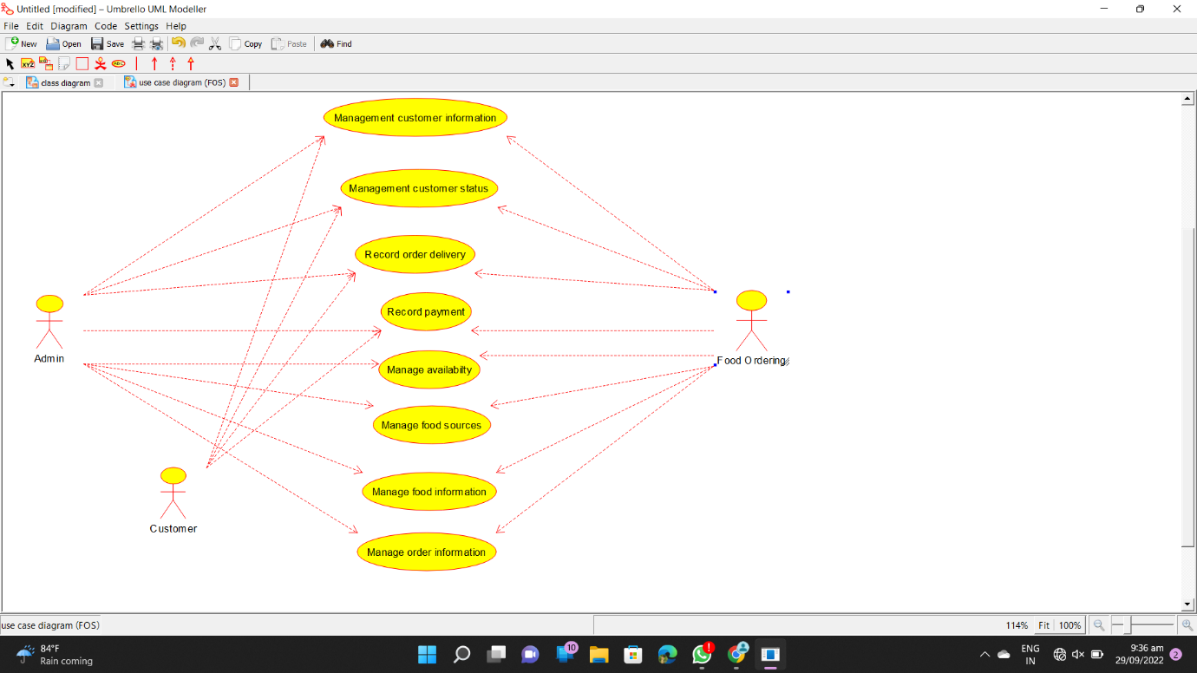

CLASS DIAGRAM :-

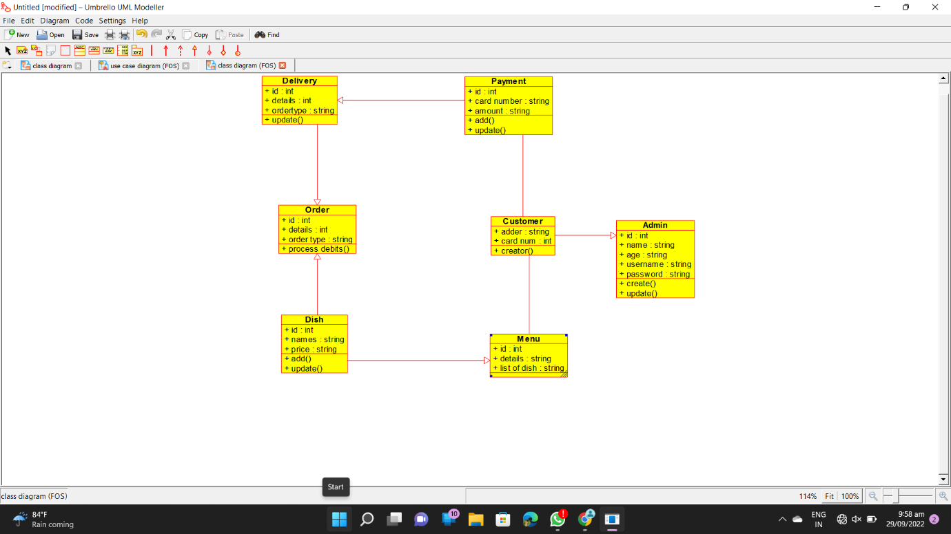

ACTIVITY DIAGRAM :- 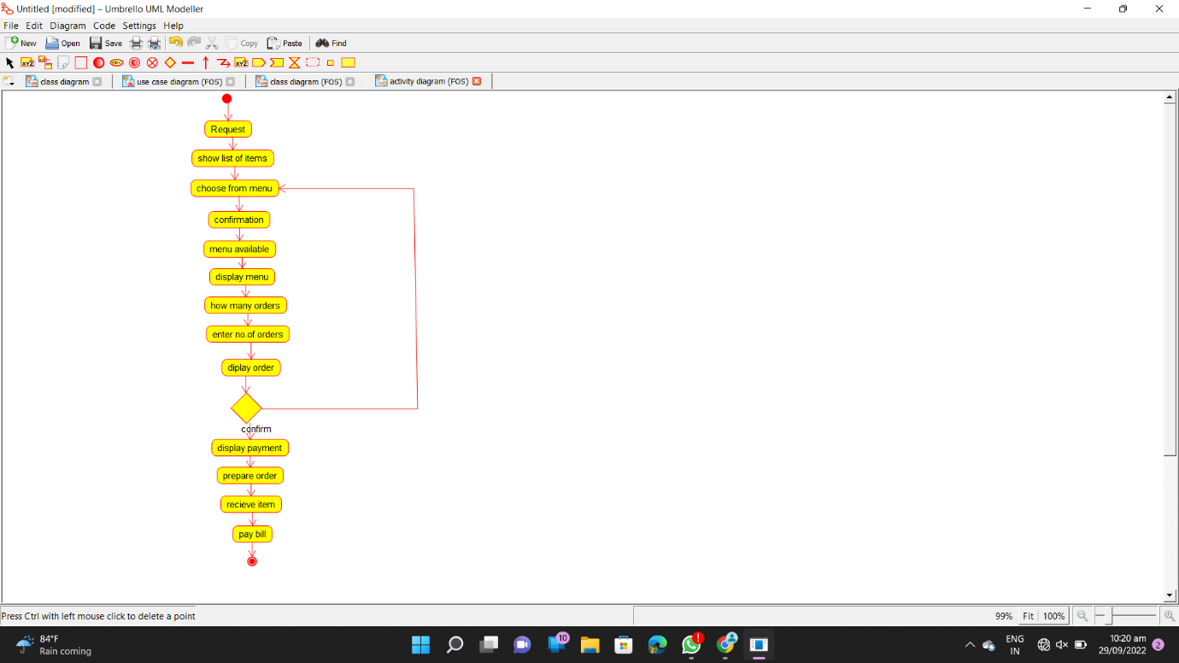

SEQUENCE DIAGRAM :-

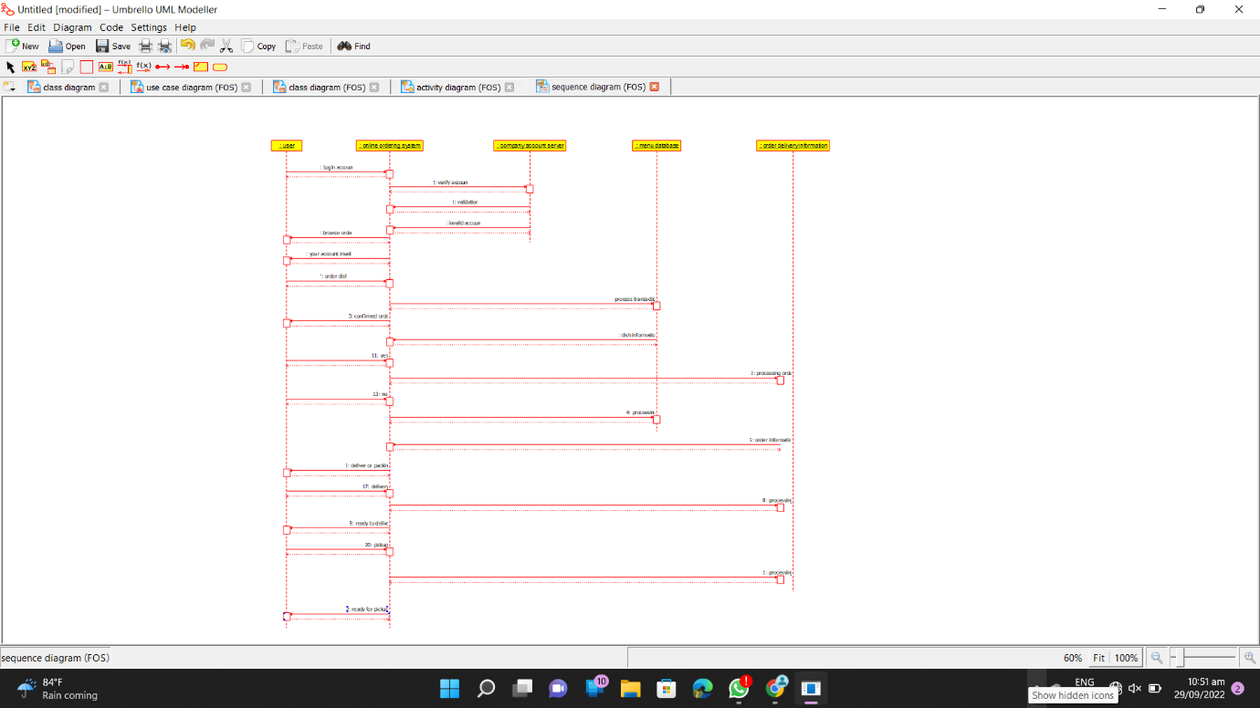

COLLABORATION DIAGRAM :- 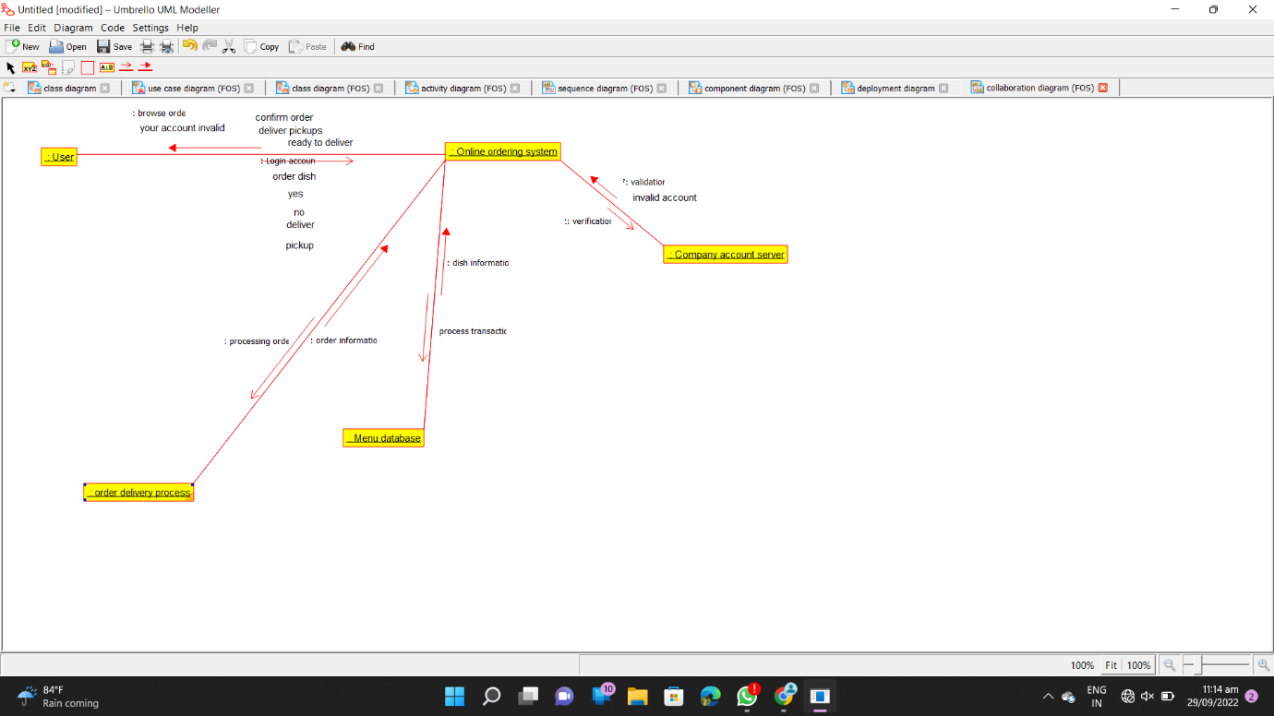

COMPONENT DIAGRAM :-

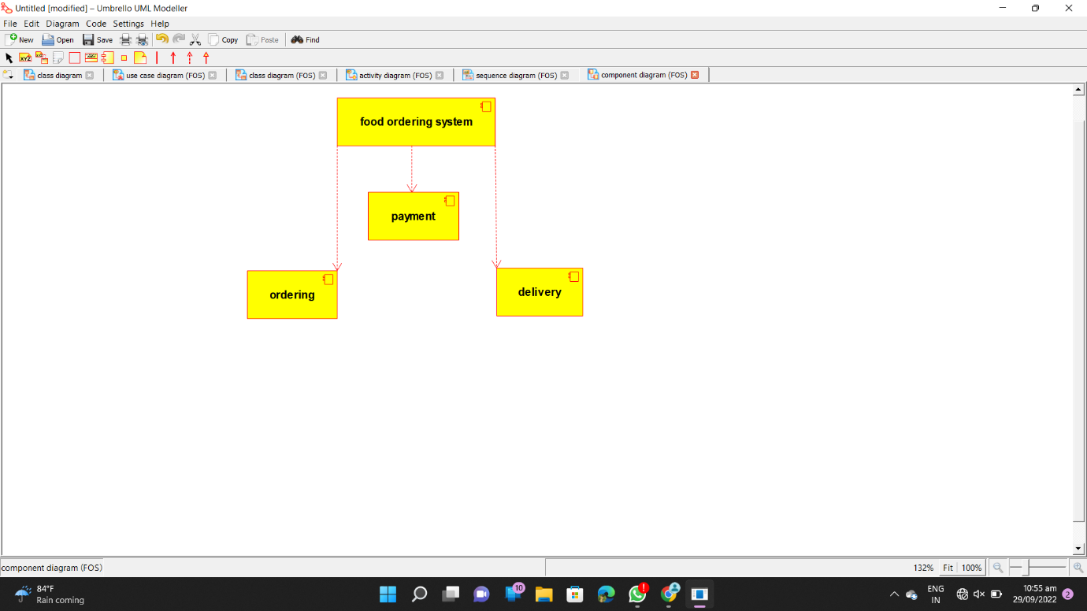

DEPLOYMENT DIAGRAM :- 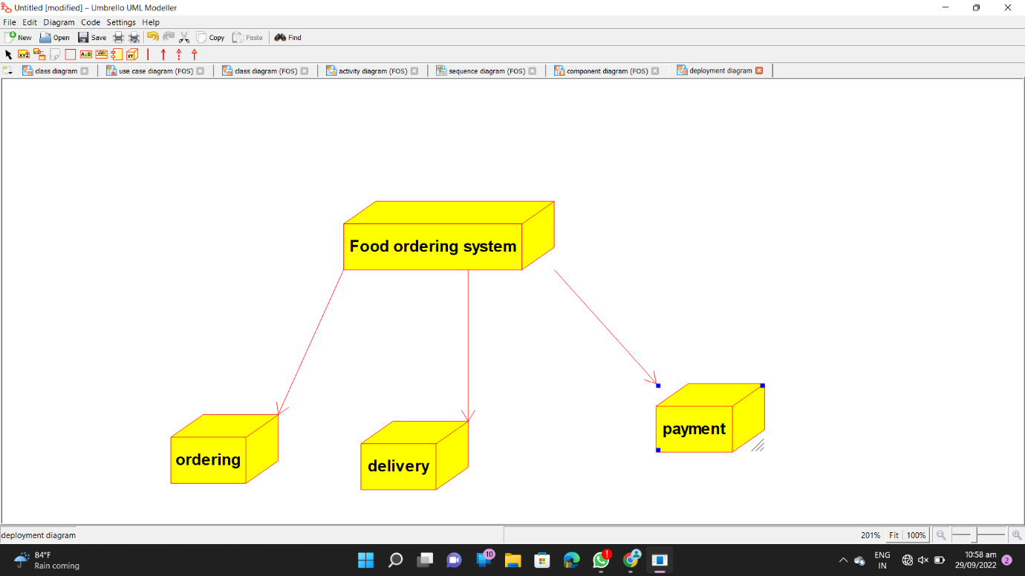

PROGRAM CODE :-

/**

* Class Admin

*/

public class Admin {

//

// Fields

//

public int id;

public String name;

public String age;

public String username;

public String password;

//

// Constructors

//

public Admin () { };

//

// Methods

//

//

// Accessor methods

//

/**

* Set the value of id

* @param newVar the new value of id

*/

public void setId (int newVar) {

id = newVar;

}

/**

* Get the value of id

* @return the value of id

*/

public int getId () {

return id;

}

/**

* Set the value of name

* @param newVar the new value of name

*/

public void setName (String newVar) {

name = newVar;

}

/**

* Get the value of name

* @return the value of name

*/

public String getName () {

return name;

}

/**

* Set the value of age

* @param newVar the new value of age

*/

public void setAge (String newVar) {

age = newVar;

}

/**

* Get the value of age

* @return the value of age

*/

public String getAge () {

return age;

}

/**

* Set the value of username

* @param newVar the new value of username

*/

public void setUsername (String newVar) {

username = newVar;

}

/**

* Get the value of username

* @return the value of username

*/

public String getUsername () {

return username;

}

/**

* Set the value of password

* @param newVar the new value of password

*/

public void setPassword (String newVar) {

password = newVar;

}

/**

* Get the value of password

* @return the value of password

*/

public String getPassword () {

return password;

}

//

// Other methods

//

/**

*/

public void create()

{

}

/**

*/

public void update()

{

}

}

import java.util.*;

/**

* Class Customer

*/

public class Customer extends Admin {

//

// Fields

//

public String adder;

public int card_num;

//

// Constructors

//

public Customer () { };

//

// Methods

//

//

// Accessor methods

//

/**

* Set the value of adder

* @param newVar the new value of adder

*/

public void setAdder (String newVar) {

adder = newVar;

}

/**

* Get the value of adder

* @return the value of adder

*/

public String getAdder () {

return adder;

}

/**

* Set the value of card_num

* @param newVar the new value of card_num

*/

public void setCard_num (int newVar) {

card_num = newVar;

}

/**

* Get the value of card_num

* @return the value of card_num

*/

public int getCard_num () {

return card_num;

}

//

// Other methods

//

/**

*/

public void creator()

{

}

}

/**

* Class Delivery

*/

public class Delivery extends Order {

//

// Fields

//

public int id;

public int details;

public String ordertype;

//

// Constructors

//

public Delivery () { };

//

// Methods

//

//

// Accessor methods

//

/**

* Set the value of id

* @param newVar the new value of id

*/

public void setId (int newVar) {

id = newVar;

}

/**

* Get the value of id

* @return the value of id

*/

public int getId () {

return id;

}

/**

* Set the value of details

* @param newVar the new value of details

*/

public void setDetails (int newVar) {

details = newVar;

}

/**

* Get the value of details

* @return the value of details

*/

public int getDetails () {

return details;

}

/**

* Set the value of ordertype

* @param newVar the new value of ordertype

*/

public void setOrdertype (String newVar) {

ordertype = newVar;

}

/**

* Get the value of ordertype

* @return the value of ordertype

*/

public String getOrdertype () {

return ordertype;

}

//

// Other methods

//

/**

*/

public void update()

{

}

}

/**

* Class Dish

*/

public class Dish extends Order, Menu {

//

// Fields

//

public int id;

public String names;

public String price;

//

// Constructors

//

public Dish () { };

//

// Methods

//

//

// Accessor methods

//

/**

* Set the value of id

* @param newVar the new value of id

*/

public void setId (int newVar) {

id = newVar;

}

/**

* Get the value of id

* @return the value of id

*/

public int getId () {

return id;

}

/**

* Set the value of names

* @param newVar the new value of names

*/

public void setNames (String newVar) {

names = newVar;

}

/**

* Get the value of names

* @return the value of names

*/

public String getNames () {

return names;

}

/**

* Set the value of price

* @param newVar the new value of price

*/

public void setPrice (String newVar) {

price = newVar;

}

/**

* Get the value of price

* @return the value of price

*/

public String getPrice () {

return price;

}

//

// Other methods

//

/**

*/

public void add()

{

}

/**

*/

public void update()

{

}

}

import java.util.*;

/**

* Class Menu

*/

public class Menu {

//

// Fields

//

public int id;

public String details;

public String list_of_dish;

//

// Constructors

//

public Menu () { };

//

// Methods

//

//

// Accessor methods

//

/**

* Set the value of id

* @param newVar the new value of id

*/

public void setId (int newVar) {

id = newVar;

}

/**

* Get the value of id

* @return the value of id

*/

public int getId () {

return id;

}

/**

* Set the value of details

* @param newVar the new value of details

*/

public void setDetails (String newVar) {

details = newVar;

}

/**

* Get the value of details

* @return the value of details

*/

public String getDetails () {

return details;

}

/**

* Set the value of list_of_dish

* @param newVar the new value of list_of_dish

*/

public void setList_of_dish (String newVar) {

list_of_dish = newVar;

}

/**

* Get the value of list_of_dish

* @return the value of list_of_dish

*/

public String getList_of_dish () {

return list_of_dish;

}

//

// Other methods

//

}

/**

* Class Order

*/

public class Order {

//

// Fields

//

public int id;

public int details;

public String order_type;

//

// Constructors

//

public Order () { };

//

// Methods

//

//

// Accessor methods

//

/**

* Set the value of id

* @param newVar the new value of id

*/

public void setId (int newVar) {

id = newVar;

}

/**

* Get the value of id

* @return the value of id

*/

public int getId () {

return id;

}

/**

* Set the value of details

* @param newVar the new value of details

*/

public void setDetails (int newVar) {

details = newVar;

}

/**

* Get the value of details

* @return the value of details

*/

public int getDetails () {

return details;

}

/**

* Set the value of order_type

* @param newVar the new value of order_type

*/

public void setOrder_type (String newVar) {

order_type = newVar;

}

/**

* Get the value of order_type

* @return the value of order_type

*/

public String getOrder_type () {

return order_type;

}

//

// Other methods

//

/**

*/

public void process_debits()

{

}

}

import java.util.*;

/**

* Class Payment

*/

public class Payment extends Delivery {

//

// Fields

//

public int id;

public String card_number;

public String amount;

//

// Constructors

//

public Payment () { };

//

// Methods

//

//

// Accessor methods

//

/**

* Set the value of id

* @param newVar the new value of id

*/

public void setId (int newVar) {

id = newVar;

}

/**

* Get the value of id

* @return the value of id

*/

public int getId () {

return id;

}

/**

* Set the value of card_number

* @param newVar the new value of card_number

*/

public void setCard_number (String newVar) {

card_number = newVar;

}

/**

* Get the value of card_number

* @return the value of card_number

*/

public String getCard_number () {

return card_number;

}

/**

* Set the value of amount

* @param newVar the new value of amount

*/

public void setAmount (String newVar) {

amount = newVar;

}

/**

* Get the value of amount

* @return the value of amount

*/

public String getAmount () {

return amount;

}

//

// Other methods

//

/**

*/

public void add()

{

}

/**

*/

public void update()

{

}

}

**20.LIBRARY MANAGEMENT SYSTEM**

USE CASE DIAGRAM:

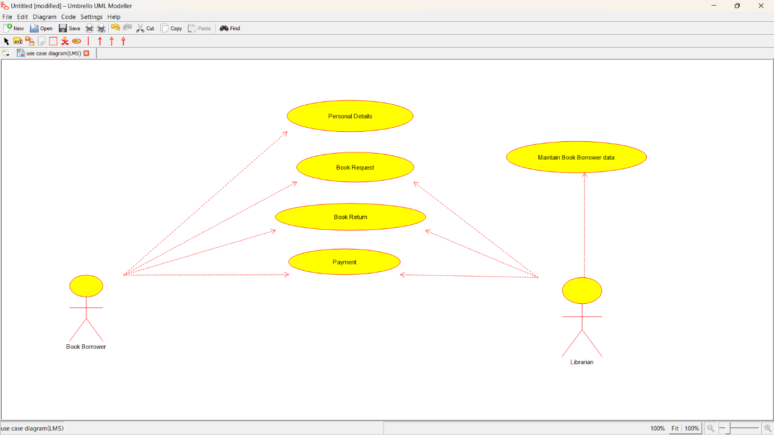

CLASS DIAGRAM:

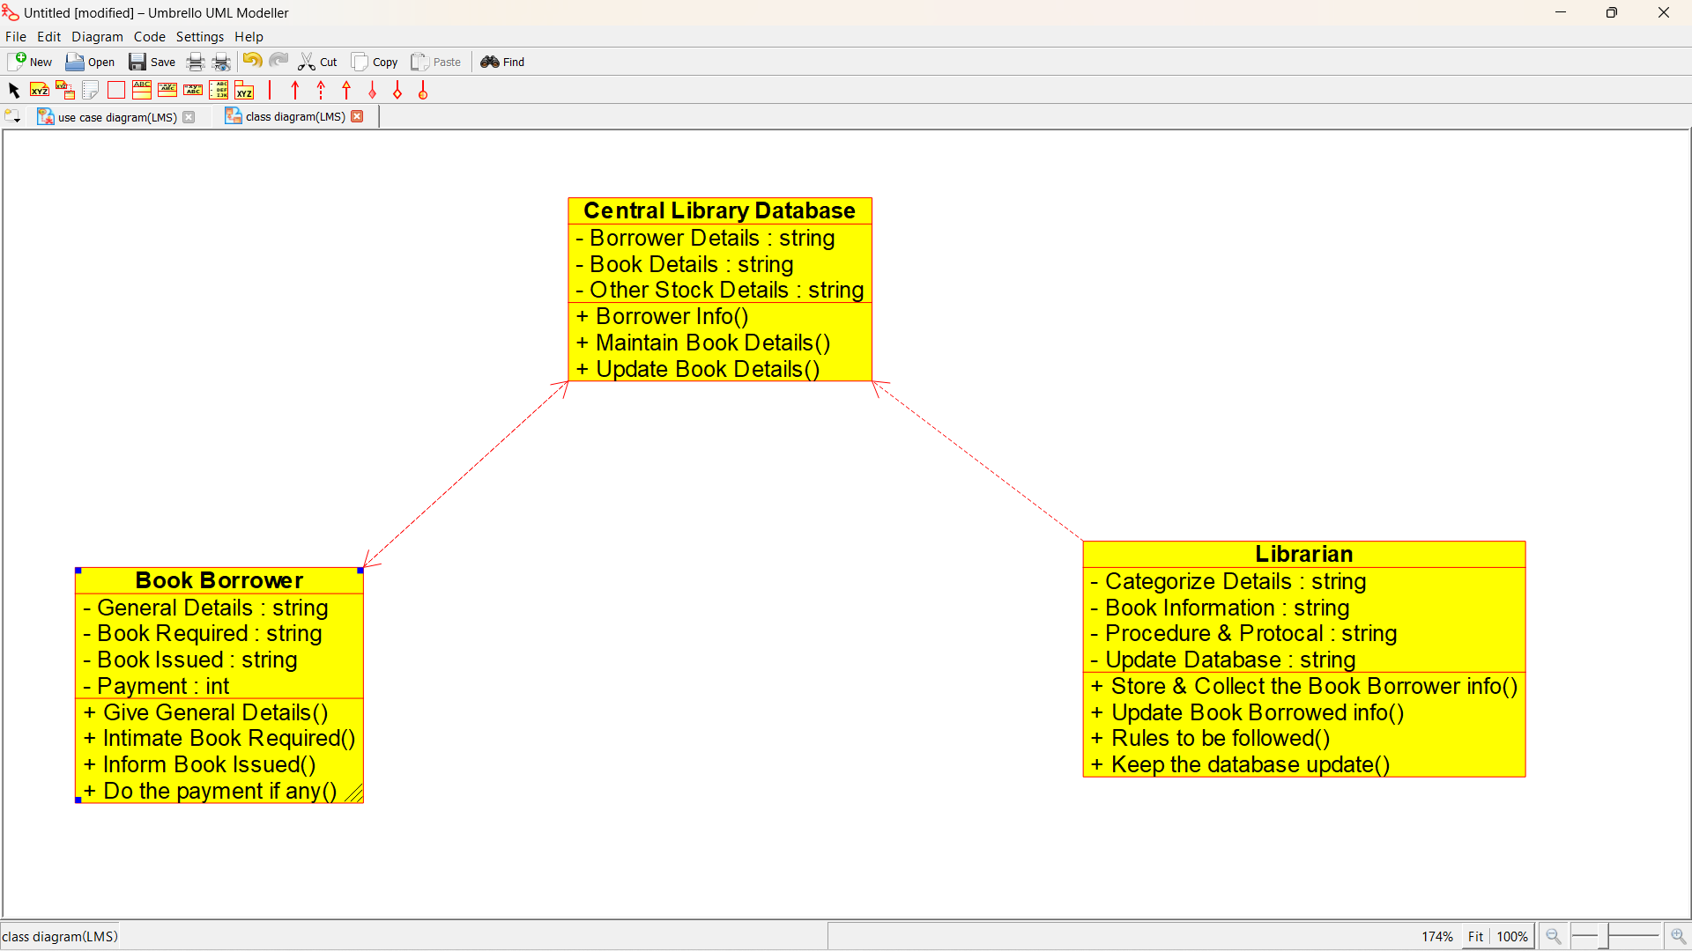

ACTIVITY DIAGRAM:

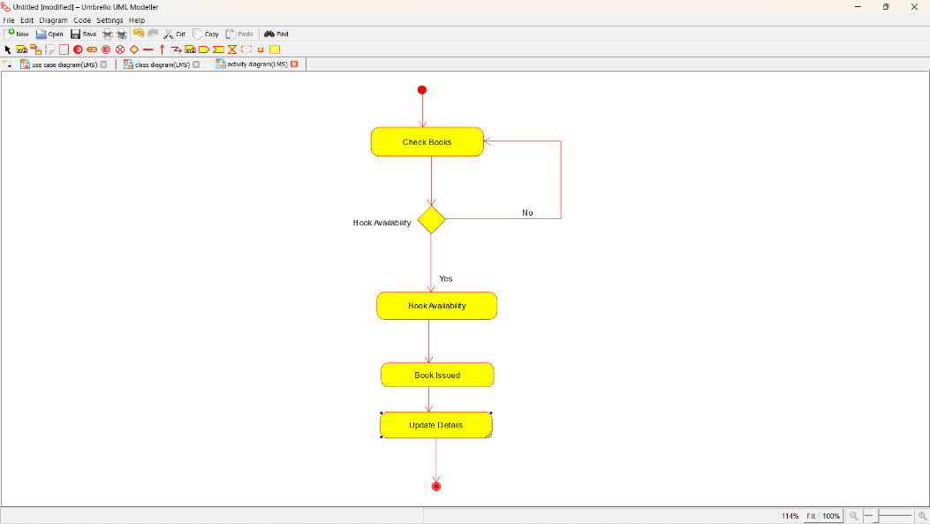

SEQUENCE DIAGRAM:

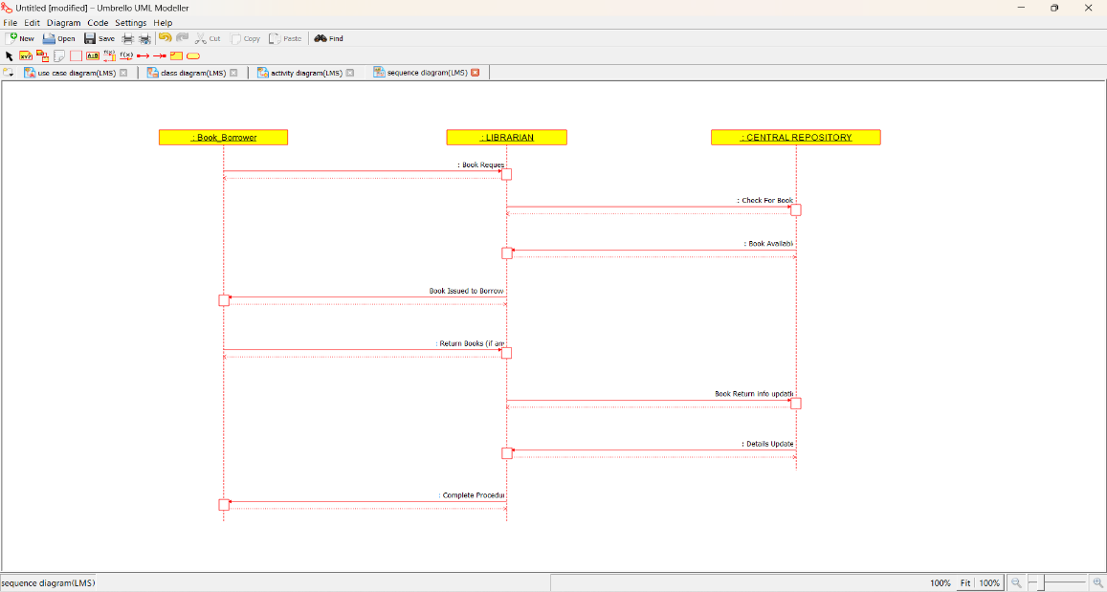

COLLABORATION DIAGRAM:

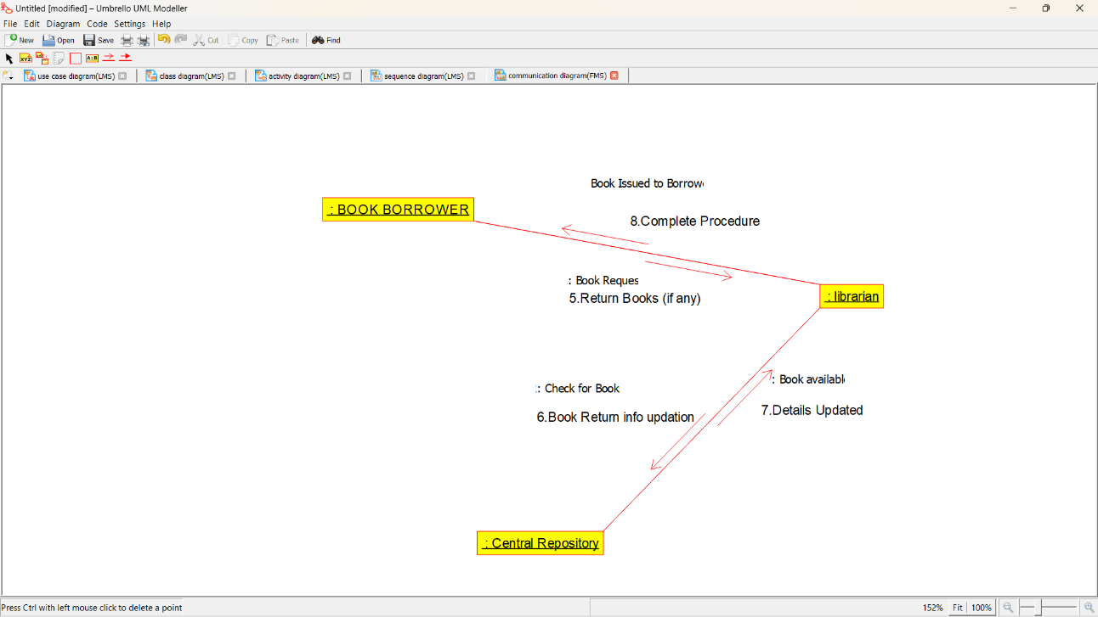

STATE CHART DIAGRAM:

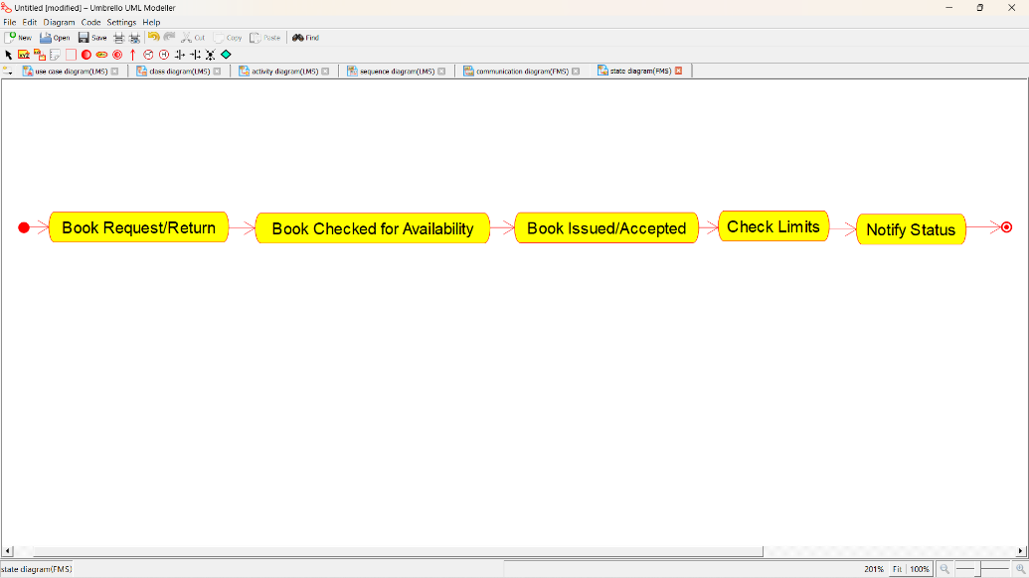

COMPOMEMT DIAGRAM:

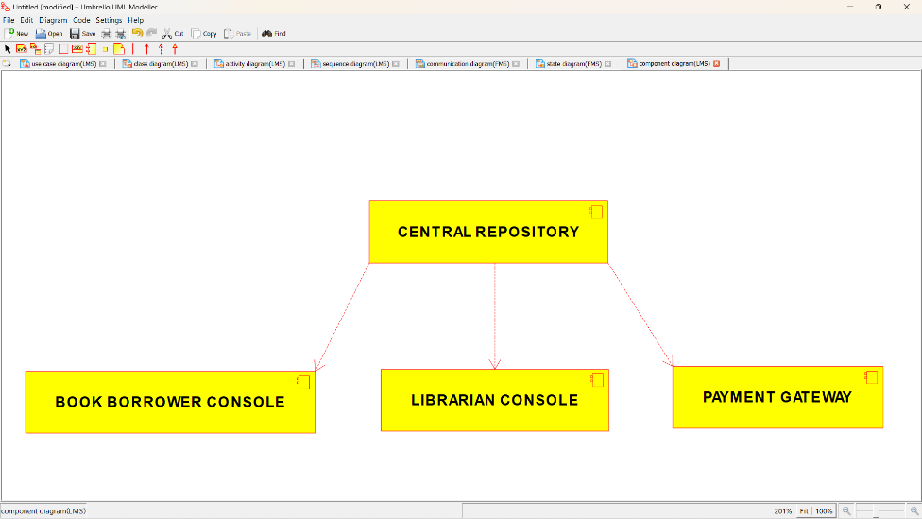

DEPLOYMENT DIAGRAM:

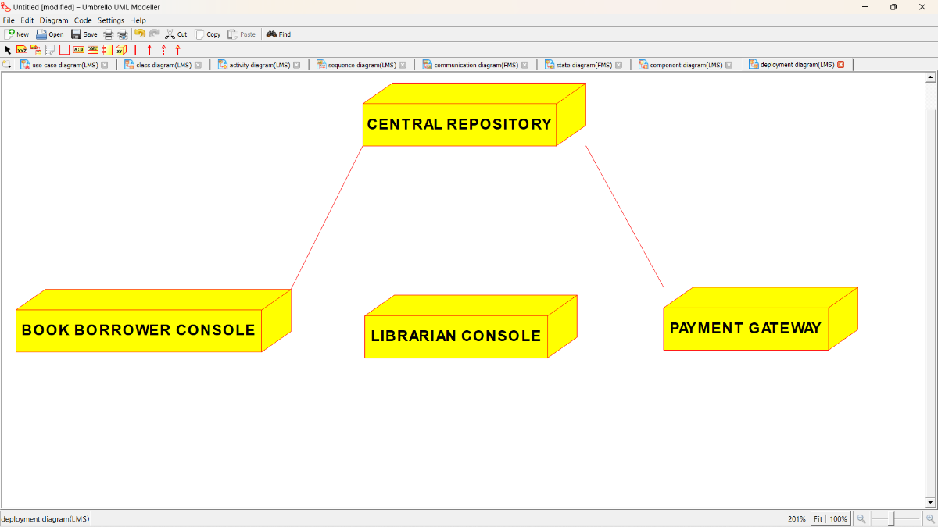

***PROGRAM CODING:***

**/\*\***

**\* Class Central_Library_Database**

**\*/**

**public class Central_Library_Database {**

**//**

**// Fields**

**//**

**private String Borrower_Details;**

**private String Book_Details;**

**private String Other_Stock_Details;**

**//**

**// Constructors**

**//**

**public Central_Library_Database () { };**

**//**

**// Methods**

**//**

**//**

**// Accessor methods**

**//**

**/\*\***

**\* Set the value of Borrower_Details**

**\* @param newVar the new value of Borrower_Details**

**\*/**

**private void setBorrower_Details (String newVar) {**

**Borrower_Details = newVar;**

**}**

**/\*\***

**\* Get the value of Borrower_Details**

**\* @return the value of Borrower_Details**

**\*/**

**private String getBorrower_Details () {**

**return Borrower_Details;**

**}**

**/\*\***

**\* Set the value of Book_Details**

**\* @param newVar the new value of Book_Details**

**\*/**

**private void setBook_Details (String newVar) {**

**Book_Details = newVar;**

**}**

**/\*\***

**\* Get the value of Book_Details**

**\* @return the value of Book_Details**

**\*/**

**private String getBook_Details () {**

**return Book_Details;**

**}**

**/\*\***

**\* Set the value of Other_Stock_Details**

**\* @param newVar the new value of Other_Stock_Details**

**\*/**

**private void setOther_Stock_Details (String newVar) {**

**Other_Stock_Details = newVar;**

**}**

**/\*\***

**\* Get the value of Other_Stock_Details**

**\* @return the value of Other_Stock_Details**

**\*/**

**private String getOther_Stock_Details () {**

**return Other_Stock_Details;**

**}**

**//**

**// Other methods**

**//**

**/\*\***

**\*/**

**public void Borrower_Info()**

**{**

**}**

**/\*\***

**\*/**

**public void Maintain_Book_Details()**

**{**

**}**

**/\*\***

**\*/**

**public void Update_Book_Details()**

**{**

**}**

**}**

**/\*\***

**\* Class Book_Borrower**

**\*/**

**public class Book_Borrower {**

**//**

**// Fields**

**//**

**private String General_Details;**

**private String Book_Required;**

**private String Book_Issued;**

**private int Payment;**

**//**

**// Constructors**

**//**

**public Book_Borrower () { };**

**//**

**// Methods**

**//**

**//**

**// Accessor methods**

**//**

**/\*\***

**\* Set the value of General_Details**

**\* @param newVar the new value of General_Details**

**\*/**

**private void setGeneral_Details (String newVar) {**

**General_Details = newVar;**

**}**

**/\*\***

**\* Get the value of General_Details**

**\* @return the value of General_Details**

**\*/**

**private String getGeneral_Details () {**

**return General_Details;**

**}**

**/\*\***

**\* Set the value of Book_Required**

**\* @param newVar the new value of Book_Required**

**\*/**

**private void setBook_Required (String newVar) {**

**Book_Required = newVar;**

**}**

**/\*\***

**\* Get the value of Book_Required**

**\* @return the value of Book_Required**

**\*/**

**private String getBook_Required () {**

**return Book_Required;**

**}**

**/\*\***

**\* Set the value of Book_Issued**

**\* @param newVar the new value of Book_Issued**

**\*/**

**private void setBook_Issued (String newVar) {**

**Book_Issued = newVar;**

**}**

**/\*\***

**\* Get the value of Book_Issued**

**\* @return the value of Book_Issued**

**\*/**

**private String getBook_Issued () {**

**return Book_Issued;**

**}**

**/\*\***

**\* Set the value of Payment**

**\* @param newVar the new value of Payment**

**\*/**

**private void setPayment (int newVar) {**

**Payment = newVar;**

**}**

**/\*\***

**\* Get the value of Payment**

**\* @return the value of Payment**

**\*/**

**private int getPayment () {**

**return Payment;**

**}**

**//**

**// Other methods**

**//**

**/\*\***

**\*/**

**public void Give_General_Details()**

**{**

**}**

**/\*\***

**\*/**

**public void Intimate_Book_Required()**

**{**

**}**

**/\*\***

**\*/**

**public void Inform_Book_Issued()**

**{**

**}**

**/\*\***

**\*/**

**public void Do_the_payment_if_any()**

**{**

**}**

**}**

**/\*\***

**\* Class Librarian**

**\*/**

**public class Librarian {**

**//**

**// Fields**

**//**

**private String Categorize_Details;**

**private String Book_Information;**

**private String Procedure_Protocal;**

**private String Update_Database;**

**//**

**// Constructors**

**//**

**public Librarian () { };**

**//**

**// Methods**

**//**

**//**

**// Accessor methods**

**//**

**/\*\***

**\* Set the value of Categorize_Details**

**\* @param newVar the new value of Categorize_Details**

**\*/**

**private void setCategorize_Details (String newVar) {**

**Categorize_Details = newVar;**

**}**

**/\*\***

**\* Get the value of Categorize_Details**

**\* @return the value of Categorize_Details**

**\*/**

**private String getCategorize_Details () {**

**return Categorize_Details;**

**}**

**/\*\***

**\* Set the value of Book_Information**

**\* @param newVar the new value of Book_Information**

**\*/**

**private void setBook_Information (String newVar) {**

**Book_Information = newVar;**

**}**

**/\*\***

**\* Get the value of Book_Information**

**\* @return the value of Book_Information**

**\*/**

**private String getBook_Information () {**

**return Book_Information;**

**}**

**/\*\***

**\* Set the value of Procedure_Protocal**

**\* @param newVar the new value of Procedure_Protocal**

**\*/**

**private void setProcedure_Protocal (String newVar) {**

**Procedure_Protocal = newVar;**

**}**

**/\*\***

**\* Get the value of Procedure_Protocal**

**\* @return the value of Procedure_Protocal**

**\*/**

**private String getProcedure_Protocal () {**

**return Procedure_Protocal;**

**}**

**/\*\***

**\* Set the value of Update_Database**

**\* @param newVar the new value of Update_Database**

**\*/**

**private void setUpdate_Database (String newVar) {**

**Update_Database = newVar;**

**}**

**/\*\***

**\* Get the value of Update_Database**

**\* @return the value of Update_Database**

**\*/**

**private String getUpdate_Database () {**

**return Update_Database;**

**}**

**//**

**// Other methods**

**//**

**/\*\***

**\*/**

**public void Store_Collect_the_Book_Borrower_info()**

**{**

**}**

**/\*\***

**\*/**

**public void Update_Book_Borrowed_info()**

**{**

**}**

**/\*\***

**\*/**

**public void Rules_to_be_followed()**

**{**

**}**

**/\*\***

**\*/**

**public void Keep_the_database_update()**

**{**

**}**

**}**